Project Assignment (Level 6): Analysing the effect of COVID-19 pandemic lockdown on UK seismic noise

# Contents

Contents

1) Contents 2

2) Abstract 3

3) Introduction 4

4) Data 5

5) Methods 5

6) Results & Analysis 6

I. Data analysis – Edinburgh 6

II. Cushendall, Northern Ireland 8

III. Hersmonceaux, Sussex 9

IV. West Acre Norfolk 10

7) References 11

# Abstract

The purpose of the project work intends to look closely at the effects of COVID-19 during the lockdown period, how anthropogenic activity during this time may be correlated with seismic noise in different regions in the United Kingdom. The data used was from Google and Apple which contained mobility data, the reasoning behind this is that the mobility data will give a single value for each parameter such as travel, retail etc. There were a few problems when receiving the seismic, such as, the data has many samples for each day, the difficulty in managing these two datasets was converting the seismic data so that it has 1 value for each day. This was then used to see if the mobility data and seismic data correlated. The Edinburgh region was the main focus of the study, the results showed this area to have a relatively high correlation between mobility & seismic noise, similar to that of Lecocq et al 2020 where the reduced levels of seismic noise was correlated with a decline in human activity during the COVID-19 pandemic.

# Introduction

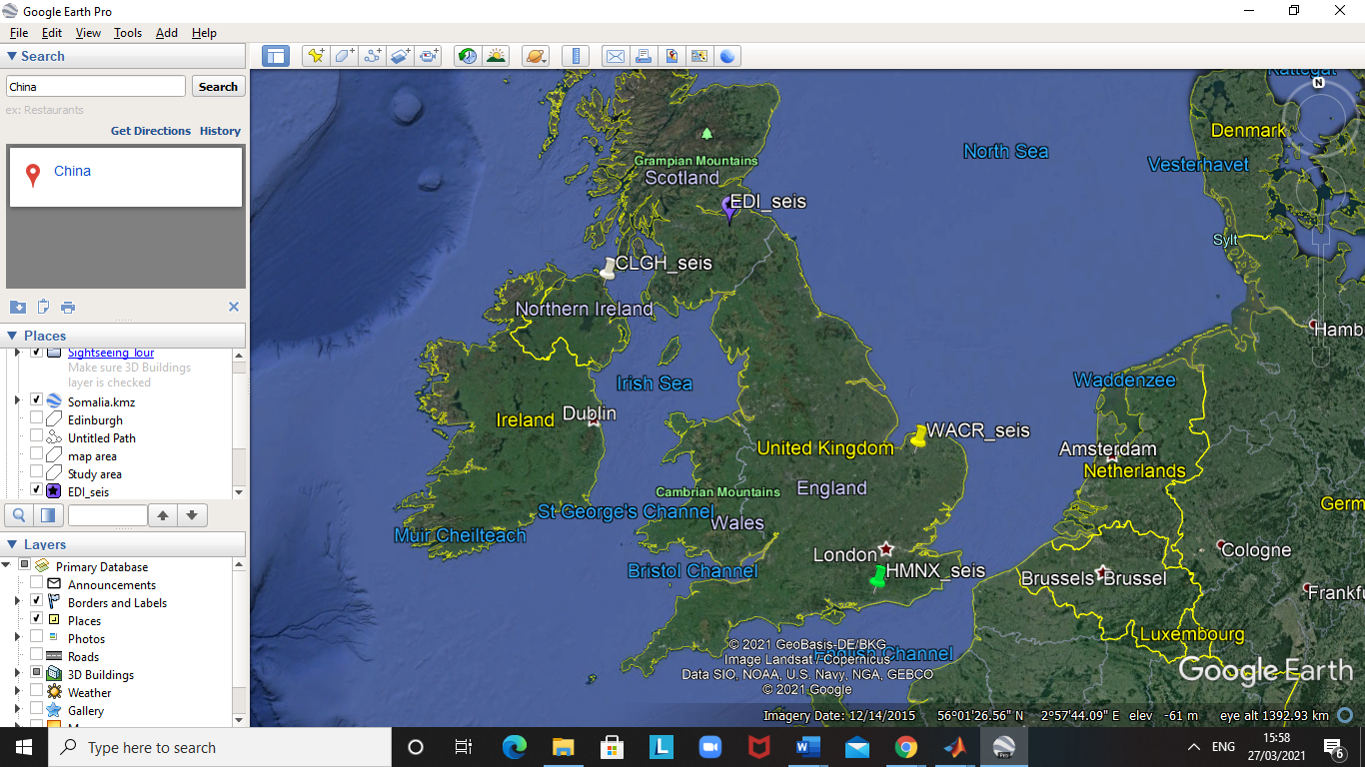The aims of this study are to analyse seismic data and mobility from four different regions in the United Kingdom, the reason for doing this is to see the relationship between seismic noise and anthropogenic activity. In a published paper by Lecocq et al 2020, the findings from their results showed that during lockdown there was a ‘reduction in seismic noise, ~ 50% in some places’. The research paper shows that during weekends and holidays, there tends to be a drop off in seismic noise, however during COVID-19 lockdown which started in March, there was an even greater decrease in high-frequency noise seismic ambient noise (hiFSAN) particularly in educational institutions. Tourism was also affected by lockdown rules as countries such as Barbados where “hiFSAN was around 50% lower than usual” (Lecocq et al 2020). This study has shown the influence of human travel and movement in relation to hiFSAN, which can be used to monitor human activity. The results from Lecocq et al 2020 stated that the longest recorded seismic reduction in noise due to changes in human activity was the 2020 seismic noise quiet period. This study used r values by way of using correlation coefficients to analyse the relationship between the two variables (mobility & seismic noise). From their findings the R values tend to be high in all regions studied, for instance Brussels, Belgium the R value was 0.94 for transport and 0.86 for retail. This indicates a strong correlation between the two variables. Similarly, another paper published by Cannata et al 2021, which used seismic data which was previously used to monitor volcanic and earthquake activity was implemented to study the affects of the lockdown on anthropogenic activity in the region of Eastern Sicily. The study from this paper used Google data and Apple data to see if there is a correlation between movement and seismic noise. From the 18 stations observed, typical patterns are seen such as quiet periods during weekends, night-time, and Christmas in busy areas (Lecocq et al 2020). This study used spearman’s correlation coefficient and then multiplied by one to make the data positive.



# Data

The two datasets given are mobility data and seismic data, the areas for the datasets include areas from: Edinburgh, West Acre (Norfolk), Cushendall (Northern Ireland) and Hersmonceaux, Sussex. The mobility data is gathered from Google, the mobility data from Google covers movement patterns such as in retail, transport, and parks etc. The start date for the Google data is the same, 15th January 2020, during a five-week span, between the 3rd of January to February 6th, 2020, the median value is used for all the data during this timeframe. Each seismic data has a Google data to do analysis with for instance, the ‘EDI_seis.mat’ is used in relation with ‘Google_Edinburgh.xlsx’.

The seismic data is recorded during a one-hour timespan per day, between 07:30 - 08:30 in the morning, this was done to analyse peak rush hour timings. The time is as UK time. Up until March 29th and after October 25th,2020, the time is GMT+1 due to the British summer time being implemented during those dates. The seismic data chosen is between a variety of stations, in total four chosen from around the United Kingdom. The variables in ‘seis’ contains 240 columns, each day consists of one and starts on January 1st, 2020 and ends on 27th August 2020. For a given row in the seismic data, it contains amplitude data. The variable ‘time’ contains time for each row given in the seismic data. ‘delta’ is another variable which contains the sample frequency for the seismic data which is 40 Hz for all stations provided.

# Methods

From the two datasets given the key point is to show if there is a relationship between seismic noise and mobility data for a given region. For the four areas which has been selected for analysis the steps taken to achieve this will be using MATLAB by way of:

* Load in the seismic data
* Plot the seismic data into the time domain
* Plot in the frequency domain
* Filtering the frequency domain (4-14 Hz) as this is where anthropogenic activity can be analysed best according to Lecocq et al, 2020
* Create loop for all 240 days (1st January – 27th August)
* Load mobility data
* Matching the time windows of both datasets (Mobility & seismic data)
* Correlating the data using R values and the ‘corrcoef’ command

This is done for the four regions selected to see the relationship between human activity and seismic noise.

# Results & Analysis

## Data analysis – Edinburgh

Once the seismic data was loaded in for Edinburgh and the data was converted to the frequency domain using the commands ‘periodogram’ and ‘log-log’, the plot showed majority of the data is predominantly low frequencies. The data is then filtered as the region of interest lies between ‘4-14 Hz as this is where anthropogenic activity is best analysed’ (Lecocq et al 2020). Comparing the filtered data with the entire data, what was seen was the filtered data shows to have a smaller range in amplitude.

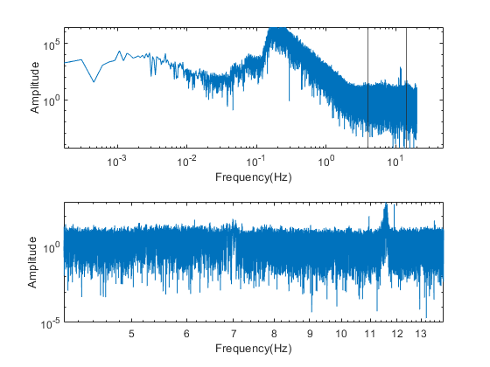

*Figure 2 – Graphs showing frequency domain with filtered data, plot at the bottom (filtered data between 4-14 Hz)*

Once this was completed the Google mobility data for Edinburgh was loaded in, this was used to compare with the seismic data. Since there was a difference in the start dates for the two data, it needed to be aligned correctly. There is a 46-day difference between the two datasets, and this was put into consideration when aligning the datasets. A subplot was then created for a side by side comparison, from my findings it shows there is a correlation between the two datasets, where there is a steep decline from ~40 days from February 15th. This is when lockdown was implemented in the UK. The correlation continues up until 110 days from February 15th which is around the same time as lockdown was relaxed and people started going outside in numbers again. However, the data is not strongly correlated, and one can assume the comparison shows more people moving around whilst there is less noise due to social distancing and less crowds in one area. This data resembles that of other studies published such as Cannata et al, 2021. Where the major areas studied in Eastern Sicily showed this trend, as well as Somala et al, 2020. Which looked at seismic noise in relation to anthropogenic activity in Shillong, India. The R values recorded (= 0.5089) are not as high as that of the other papers such as Lecocq et al, 2020, or Cannata et al, 2021.

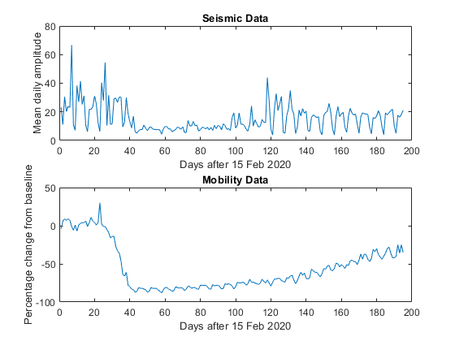

Steep decrease in mobility

Lockdown relaxed

Start of lockdown

*Figure 3- Graphs showing seismic data (top) & Mobility data (Bottom). Dashed lines represent the start & relaxation of lockdown – Plots created in MatLab*

## Cushendall, Northern Ireland

When analysing data in this region it is much quieter than that of Edinburgh, this could be due to the difference in population where Edinburgh has an estimated population of 513,210 according to Edinburgh government website. [1]. Cushendall has an estimated population of 1,278 [2].

There is one clear spike in this data at around 13th September 2020, this may be due to the Category 1 hurricane which affected the area around this same time and may have led to a large anomaly in the seismic reading. According to government health website Garda, it published the warning which coincides with the spike in this area. [3]. The correlation between the two datasets show to be very weak (=0.0678), this may be due to the one large anomaly caused potentially by the Hurricane on September 13th, 2020.

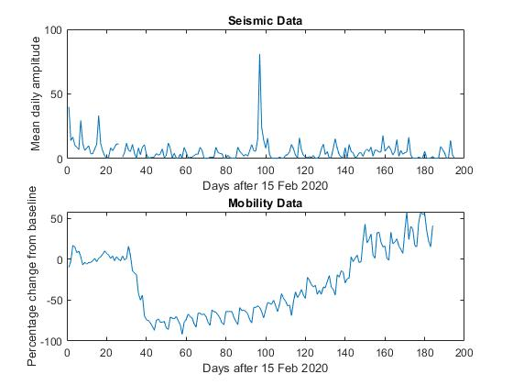

*Figure 4- Graphs showing seismic data (top) & Mobility data (Bottom). Dashed lines represent the start & relaxation of lockdown – Plots created in MATLAB*

Hurricane Paulette?

## Hersmonceaux, Sussex

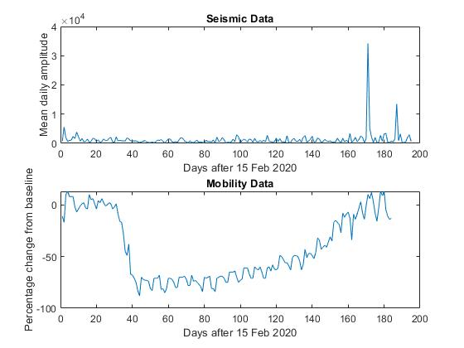

Steep decrease ~ lockdown beginning

Large spike ~ 12th & 13th September (Reached 30 degrees Celsius)

*Figure 5- Graphs showing seismic data (top) & Mobility data (Bottom). Dashed lines represent the start & relaxation of lockdown – Plots created in MATLAB*

The dataset has an R = 0.2194 which is weakly correlated. Perhaps the removal of that spike which occurred on a weekend when temperatures reached 31 degrees Celsius according to Sussex live website [4]. A lot of people may have gone outside, this may have skewed the dataset and ruined the potential for a better fit positive correlation.

## West Acre Norfolk

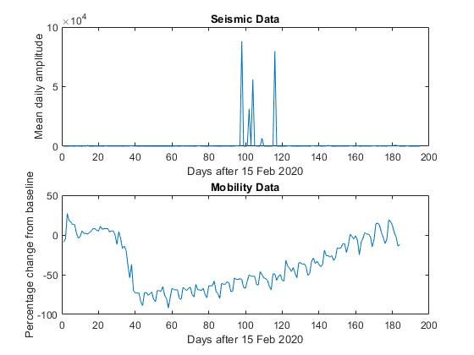

Large spikes occurring ~25/05/20, peak summertime?

*Figure 6- Graphs showing seismic data (top) & Mobility data (Bottom). Dashed lines represent the start & relaxation of lockdown – Plots created in MATLAB*

# References

*[1] - The City of Edinburgh Council. 2021. Edinburgh's population – The City of Edinburgh Council. [online] Available at: <https://www.edinburgh.gov.uk/strategy-performance-research/edinburghs-population/1> [Accessed 26 March 2021].*

*[2] - Ninis2.nisra.gov.uk. 2021. NINIS: Northern Ireland Neighbourhood Information Service. [online] Available at: <https://www.ninis2.nisra.gov.uk/public/AreaProfileReportViewer.aspx?FromAPAddressMulipleRecords=Cushendall@Exact%20match%20of%20location%20name:%20@Exact%20Match%20Of%20Location%20Name:%20Cushendall@23?> [Accessed 27 March 2021].*

*[3] - GardaWorld. 2021. Bermuda: Paulette intensifies into Category 1 hurricane, forecast to bring hazardous conditions from September 13 /update 1. [online] Available at: <https://www.garda.com/crisis24/news-alerts/378751/bermuda-paulette-intensifies-into-category-1-hurricane-forecast-to-bring-hazardous-conditions-from-september-13-update-1> [Accessed 27 March 2021].*

*[4] - Fiorillo, C. and Gladwin, A., 2021. Sussex set for 'one last blast of summer' with temperatures hitting 31C. [online] sussexlive. Available at: <https://www.sussexlive.co.uk/news/sussex-news/sussex-weather-sussex-set-one-4511642> [Accessed 24 March 2021].*

*Somala, S.N. (2020). Seismic noise changes during COVID-19 pandemic: a case study of Shillong, India. Natural Hazards, 103(1), pp.1623–1628.*

*Cannata, A., Cannavò, F., Di Grazia, G., Aliotta, M., Cassisi, C., De Plaen, R.S.M., Gresta, S., Lecocq, T., Montalto, P. and Sciotto, M. (2021). Seismic evidence of the COVID-19 lockdown measures: a case study from eastern Sicily (Italy). Solid Earth, 12(2), pp.299–317.*

*Lecocq, T., Hicks, S.P., Van Noten, K., Van Wijk, K., Koelemeijer, P., De Plaen, R.S., Massin, F., Hillers, G., Anthony, R.E., Apoloner, M.T. and Arroyo-Solórzano, M., 2020. Global quieting of high-frequency seismic noise due to COVID-19 pandemic lockdown measures. Science, 369, 1338-1343, doi:10.1126/science.abd2438*